AI Implementation

Table of Contents
AI Implementation 1
Goal 1
Choice of AI 1
Reasons for dropping Google Gemini 2
Reasons for using Groq 2
Implementation process 2
Obtaining Groq API 2
Library used 2
Services created (server/services/groq.js) 3
Controller, route combo created (server/routes/ai.js) 3
Trace of AI feature 3
1) CreateRecipe.tsx / EditRecipe.tsx 3
2) routes/ai.js 3
3) services/groq.js 3
Instructions for using AI feature 3
Create page/ Update page 3

Goal
Implement a feature where users can toggle a button in the create or edit recipe page to allow AI to generate appropriate tags based on the relevant ingredients. To similify implementation, we have decided against a live preview of the generated tags to prevent spamming the feature.

Choice of AI
INITIAL CHOICE (Gemini-2.0-flash)
We chose Google Gemini to implement a feature using AI to generate recipe tags. Gemini-2.0-flash is provided with the free tier and is used for the project
LATTER CHOICE (Groq llama-3.3-70b-versatile)
Due to the inadequate quota limits provided by Google Gemini, we decided to switch to using Groq to implement the AI tags feature. Groq is an API service which allows us to run open-source models such as Llama and Mixtral with a more generous usage quota.
More specifically, the feature will use the llama-3.3-70b-versatile model which has 30 RPM, 1000 RPD, 12000 TPM and 100,000 TPD (Groq). This quota was able to accommodate rigorous testing of prompt results without hitting the limit.

Reasons for dropping Google Gemini
- In adequate free usage quota

Reasons for using Groq
- Adequate free usage quota
- “Open-source” models allow very permissive license, though this is not a major concern for a small project

Implementation process

Obtaining Groq API
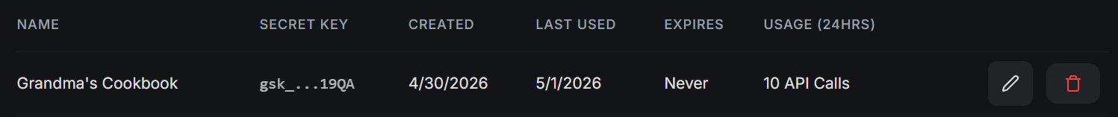

Library used
groq-sdk

Services created (server/services/groq.js)
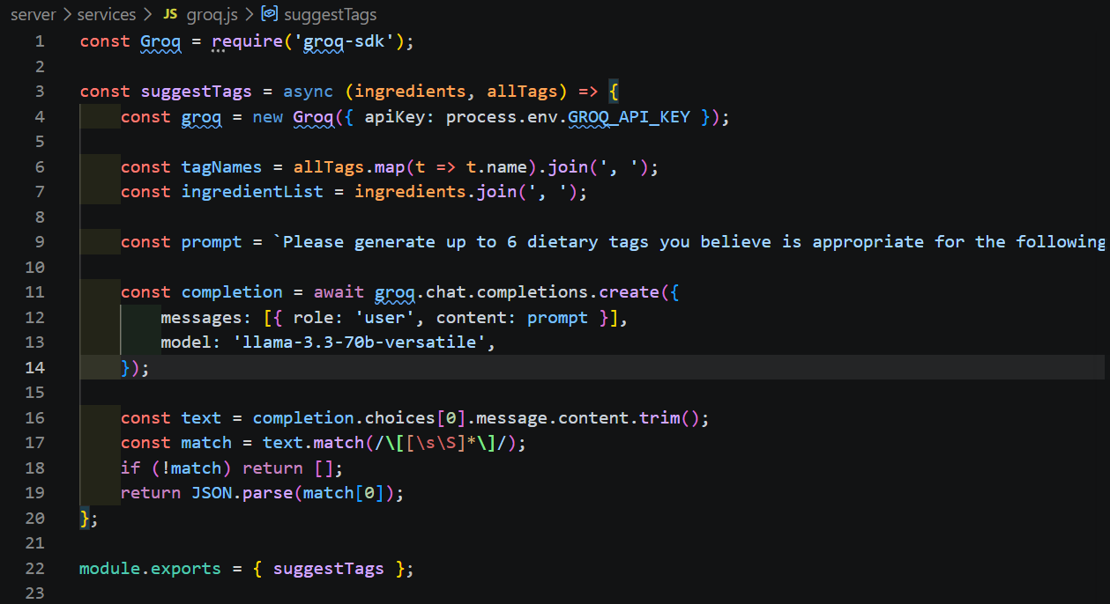

Controller, route combo created (server/routes/ai.js)

Trace of AI feature

1) CreateRecipe.tsx / EditRecipe.tsx
User toggles the AI button
On submit, it calls '/ai/suggest-tags' with given ingredients and already selected tags if they exist.

2) routes/ai.js
Fetches all tags from tags table in database
Filters out already selected tags to prevent duplicates when prompting
Calls suggestTags in /services with the ingredients and remaining tags

3) services/groq.js
Builds a prompt using ingredients list and all available tags
Sends the prompt to Groq’s llama-3.3-70b-versatile model using groq-sdk
Used regex to extract only the array in the response
Return the array of suggested tags

Instructions for using AI feature

Create page/ Update page
Toggle the AI feature button next to the “Tags” label.
The button will display a pop-up explanation when hovered
(Create page) Continue with filling the create page and create the recipe
(Update page) Continue with update process and update the recipe
New suggested tags should appear on the recipe page

